**UNIVERSIDAD DE LAS FUERZAS ARMADAS – ESPE**

**CAREER**

**SOFTWARE ENGINEERING**

**SUBJECT**

**FUNDAMENTALS OF ENGINEERING**

**Team 03 Gamers**

**Topic: Mobility in the Quito’s Subway**

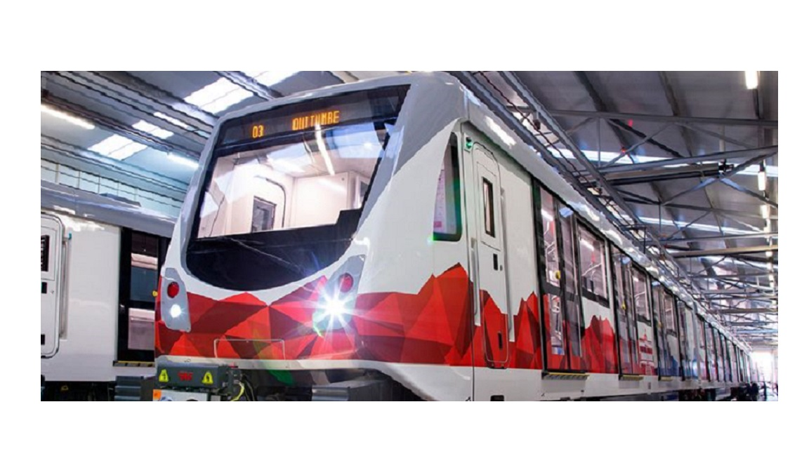

**Integrant**

**MASAPANTA GUILCATOMA JEFFERSON SANTIAGO**

**MIDEROS CRUZ SAMIR ESTEBAN**

**MOLINA GUAICO GUSTAVO STIVEN**

**MORALES SOSA JEIMY MARLEY**

**ORRICO EMME CAMILO ANDRES**

**UNIVERSIDAD DE LAS FUERZAS ARMADAS – ESPE**

User story

1.- The user told us that to enter the subway station the first thing to do is to buy a card, which came included with a recharge of 13 trips, after that tour he walked to the ticket office and at that very moment he can choose where he will go, after that pass the card to register the trip and once passed the card digitally, a trip is deducted, from there he went down some escalators and went to the subway platform where he waited for the subway when the subway arrived the doors opened automatically because if not he could press a button, only if it was in green because if it was in red/orange it will not let you press it and the subway will stop for about 30 minutes.

2.- Mobility only in the city

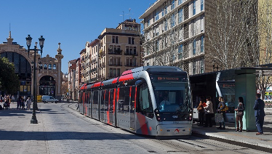

To purchase the ticket to enter the tram, tickets are purchased at the same stop.

Different tickets:

**One trip ticket:** paying 1.40 each trip

**Ticket with several trips and pay your friends:** paying € 5 or at most € 50 having a card which is economical because you can make transfers, that is, for an hour you can pay € 1.40 and get on the tram several times, but not from the same stop, this card is also valid to get on the bus.

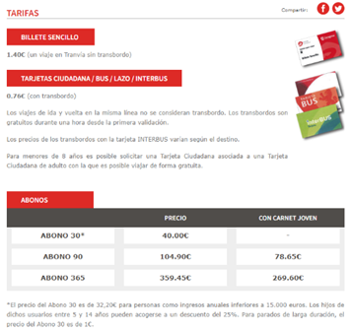**Tickets for season tickets 30, 90, 365**days: with this, you can get on the tram and the bus as many times as you want, but only by paying for your ticket, you can not pay your friends.

**TYPES OF CARDS AND BONUSES**

Mobility to go to another city

To purchase the ticket can be from the station (where you taker the ave or train) or online, the price varies according to the destination, if you buy the ticket with a month off before traveling and leave little cheaper than taking it the same day:

Example:

Hor trip to Madrid, a trip of 1 hour and 19 minutes

Trip for January 3, buying it from today

- The system shall use a multimodal card.

- The system shall allow the passengers to resort to an emergency button.

-The system shall start with a login where the user introduces his ID or passport ID and a password.

-The system shall have the option to register or create an account.

-The system shall allow users to recharge the multimodal card through deposits, transfers, and payments to counters.

-The system shall have access to the register of control and the list of the employees only for the administrators.

-The system shall share the schedule with the passengers.

-The system shall allow the passengers to use an emergency button in case of a dangerous situation.